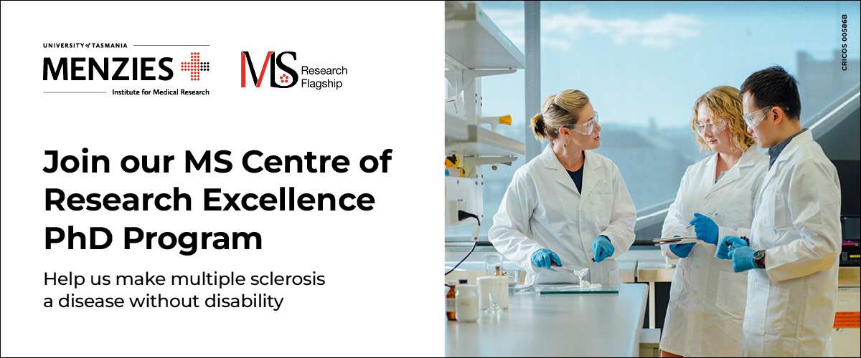
The MS Research Flagship and MS Centre of Research Excellence (MS-CRE) at the Menzies Institute for Medical Research is currently recruiting national and international PhD students across a range of disciplines.
The MS-CRE has a shared vision, to make MS a disease without disability; harnessing the power of interdisciplinary teams in neuroscience, genetics, bioinformatics, drug development, and clinical trials to fast track the discovery and evaluation of drug treatments and biomarkers for progressive MS.
Successful applicants will join one of the largest MS research groups in the world and work collaboratively with academics, industry, not for profit and consumer partners. The MS-CRE provides a unique environment for training, mentoring and developing the next generation of research leaders.
Find out more:
- The impact of multiple sclerosis genetics on the brain
- Vascular dysfunction in multiple sclerosis
- Genomics informed drug repurposing in multiple sclerosis
- Innovating clinical trial design in multiple sclerosis
Location: Hobart, Tasmania, Australia
Scholarship: $33,511 + $7,500 top-up per year for 3.5 years (indexed annually)
Closing date: 1 October 2025

